
Dashboard Design

Date | 1 November 2026
Team ID | Not provided — enter the official assigned Team ID before submission
Project Name | F1 Race Intelligence: Formula 1 Performance Analytics using Tableau
Maximum Marks | 5 Marks

Activity 1: Interactive and visually appealing dashboards
Creating an effective Streamlit dashboard involves presenting business data stored in Snowflake through clear, interactive, and easy-to-understand visualizations. Students should design the dashboard so that users can quickly understand important KPIs, trends, comparisons, and business insights.
- Clear and Intuitive Layout
- Use Appropriate Visualizations
- Colour and Theming
- Interactive Filters and Slicers
- Drill-Down Capabilities
- Responsive Design
- Custom Visuals and Icons
- Use of Infographics

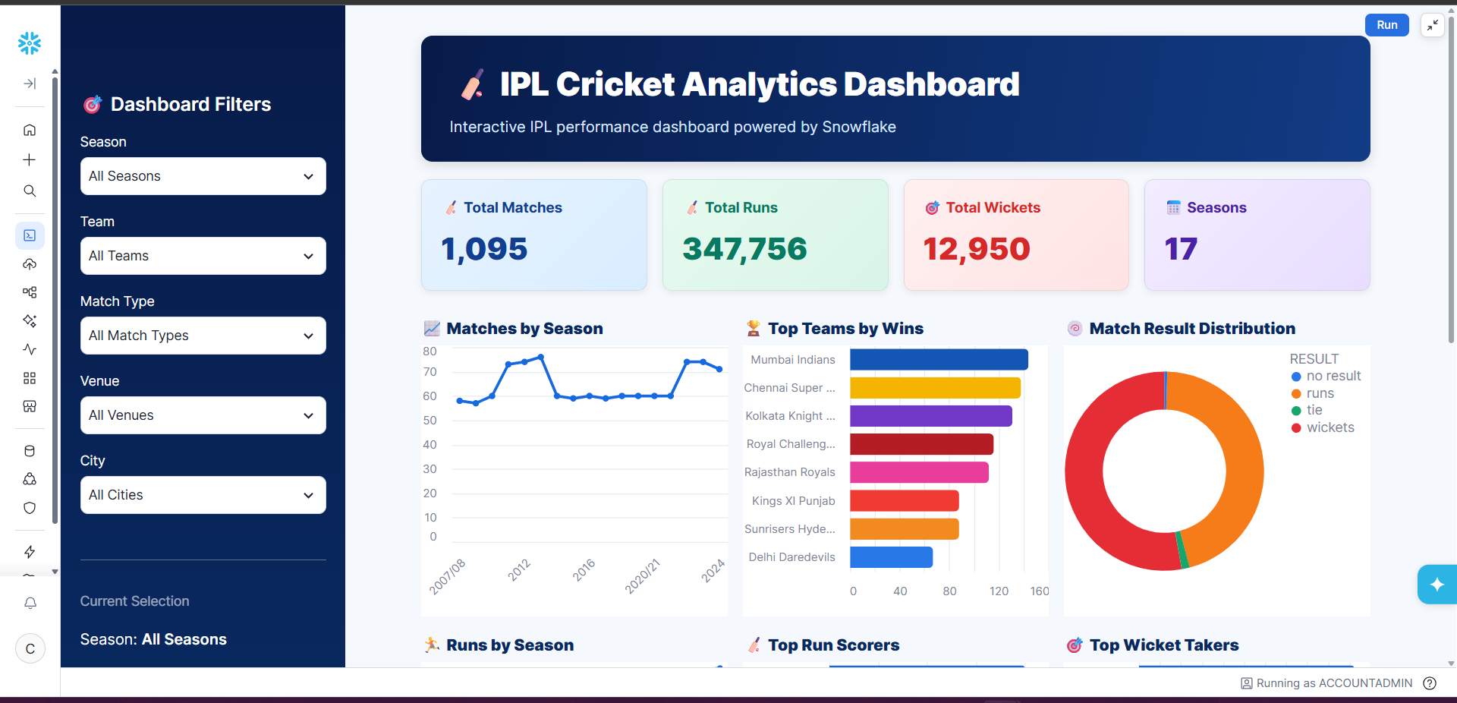
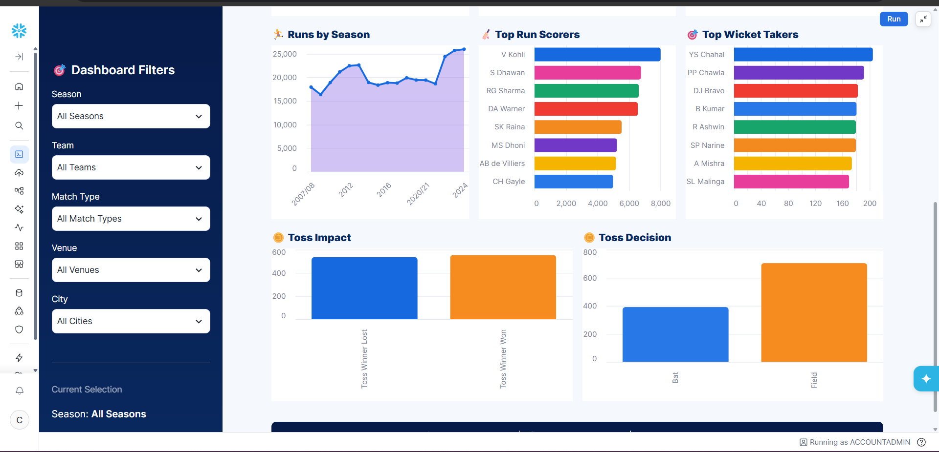
Note: Highlight the major outcomes in form of bullet points
Sample:
Here are five potential outcomes from the dashboard image provided:
- Championship comparison: rank drivers or teams by points, wins, podiums or poles where those views exist in the workbook. Do not claim a ranking until it is verified from the actual chart.
- Driver and team performance comparison:
V. Kohli leads the Top Run Scorers chart, followed by players such as S. Dhawan, RG Sharma, and DA Warner. This highlights the importance of high-performing batsmen.
- Qualifying and lap pace comparison: use qualifying gap, lap time, sector time and speed-trap measures only where the actual workbook contains those views. Explain units and circuit context.
- Reliability analysis:
The Toss Impact and Toss Decision charts show differences between winning after winning the toss and choosing to bat vs. field. This can be used to investigate whether the toss provides a meaningful advantage.
- Season and circuit trends: compare race counts and performance metrics by season only where supported by the source data; confirm that season coverage and values are valid before describing a trend.
Overall outcome: the dashboard should support evidence-based comparison of F1 performance and reliability. Report only patterns visible in the actual workbook and state relevant limitations.

Proposed Snowflake-backed dashboard design
This template describes a future Snowflake-backed option. The current verified published analytics are Tableau Public plus the supplied Excel workbook; a Snowflake dashboard is not verified as deployed.
KPI row: race-result row count, distinct seasons, distinct circuits, DNF count/rate and qualifying records. Display data freshness/provenance alongside KPIs.
Core views: championship points by driver/team/season; qualifying gap to pole; lap-time distribution by compound and tyre age; DNF rate by team/circuit type; pit-stop measures where definitions are reliable.
Filters: season, team, driver, circuit, circuit type and tyre compound. Use denominator-aware rates and preserve an Unknown category for missing DNF reasons.
Quality gates: validate counts, duplicate business keys, null distributions and aggregate reconciliations before exposing curated views to Tableau.
Major outcomes: a warehouse would make repeatable cleaning and SQL-based aggregation easier at larger scale, but only after the account, schema, ingestion and execution evidence exist.

